 OCTOBER 2025
Monday  SAT 2024 TEST DATES  Oct. 4, 2025, reg. by 9/19  Nov. 8, 2025, reg. by 10/24  Dec.6, 2025, reg by 11/21  SEE ACCESS ADISOR | Tuesday  Lincoln Lane Foundation Sch. Due November. 15, 2025  3.0 GPA REQ/4 Yr. College/Univ.  Apply at: linanefoundation.org  /To -apply | Wednesday  Meet with College Rep’s and  Military Recruiters on:  WEDNESDAYS  1st MILLITARY ASVSB TEST DATE  Tuesday OCT. 14, 2025 | Thursday  Filing for: FINANCIAL AID  TO ATTEND COLLEGE BEGINS:  October 1st, 2025  SEE ACCESS ADVISOR To Schedule  an Appointment | Friday  Enjoy Autumn  
PSAT TESTING OCT 1 -31  END OF COURSE WRITING 10/20-10/31 “ONLY” for 9 -12 “ENROLLED” in English 11 | Pre-GED TESTING | 1  READING WORK-KEYS | Pre-GED TESTING 2  . | 3  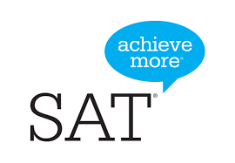  *SAT TESTING OCTOBER 4, 2025
ATTENDANCE MEETING 6 | Pre-GED TESTING 7  WRITING WORK-KEYS | 8    TIDEWATER COMMUNITY COLLEGE  MARYMOUNT UNIVERSITY | Pre-GED TESTING 9 | 10
ATTENDANCE MEETING 13  SENIORS ONLY!!   | Pre-GED TESTING  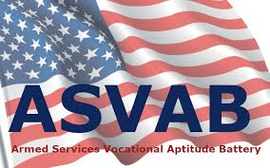  ASVAB TESTING | 15  TIDEWATER COMMUNITY COLLEGE | Pre-GED TESTING 16 | 17
ATTENDANCE MEETING 20  Virginia Collage Appl. Week  9th Grade Classroom Guidance | Pre-GED TESTING 21  Virginia Collage Appl. Week  9th Grade Classroom Guidance | 22  Virginia Collage Appl. Week  QUARTER 1 ENDS | Pre-GED TESTING 23  Virginia Collage Appl. Week | 24  Virginia Collage Appl. Week
ATTENDANCE MEETING 27  TEACHER WORKDAY/PROF DEV. | Pre-GED TESTING 28 | NPS COLLEGE FIELD TRIP 29   | Pre-GED TESTING 30 | 31  

